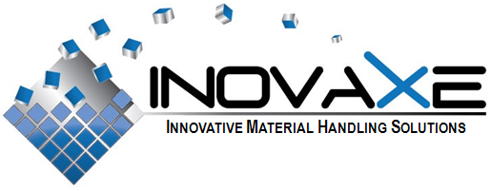

FOR IMMEDIATE RELEASE

Contact:
Inovaxe Corporation
Deerfield Beach, FL
954.531.1363
E-mail: info@inovaxe.com
www.inovaxe.com

Inovaxe Introduces Logistics Services for Offshore Manufacturing

DEERFIELD BEACH, FL — October 2010 — Inovaxe, a world leader and provider of innovative material handling and inventory control solutions, is pleased to introduce its Logistics Services Division to help small to mid-sized companies deal with the complexity and cost of using offshore manufacturers.

There are many hidden costs when using offshore manufacturers that can become very expensive when USA-based personnel must be sent to perform them in person. Inovaxe allows its customers to take advantage of the company’s offshore employees to perform these tasks to help reduce overall costs.

The following are the Logistics Services offered by Inovaxe:

- Initial inspection of potential vendors including: Size of facility, number of buildings with square footage, power cycling to facility, ability to generate their own power for factory equipment, equipment list, type of equipment, general condition of equipment, maintenance schedules, tool handling process (including maintenance and storage), number of employees, minimum age of employees, training programs for employees, etc.

- First Article Inspection: Get a First Article Report from the manufacturer, review the report to see that critical dimensions are within the tolerance of drawings, verify that tolerances of drawings are being used as the tolerances for First Article Report, measure the overall dimensions, measure the critical dimensions and compare to First Article Report.

- Production In-Process Inspection: Verifying instructions are available to workers for Inovaxe’s in-process inspection, training program for products being run, and review of in-process inspection data.

- Pre-Shipment Inspection: Random inspection of parts prior to packaging (general appearance, finish to drawings/specification, critical dimensions, part markings, functionality), packaging (text and quality of sealing), proper shipping carton material, carton printing and colors, packing of cartons to customers specifications, and verify package count.

- Vendor Sourcing: Find potential vendors for customers that have the ability to perform specifications called out in drawings and meet target pricing. Companies also should consider using Inovaxe’s Initial Inspection of Potential Vendors for new vendors found that appear to meet outsourcing requirements.

- Order parts through Inovaxe: Use the company’s established vendors to have custom parts produced. Users can take advantage of the large number of varied capability vendors that Inovaxe currently uses to reduce the risk and time when starting up new vendors.

For more information about Inovaxe’s Logistics Services, contact Russ Blagg at russ.blagg@inovaxe.com or visit www.inovaxe.com.

###
About Inovaxe Corporation
Inovaxe Corporation is focused on delivering innovative production and inventory management solutions to the electronics industry. The Company’s product offering includes ambient air and MSD Material Storage Hardware (InoCart), a Supply Chain Management System (InoVision) and a Procurement Program (InoSource). For more information and a demonstration of Inovaxe products, visit www.inovaxe.com.

